**LED CHASER**

**CIRCUIT DIAGRAM:-**

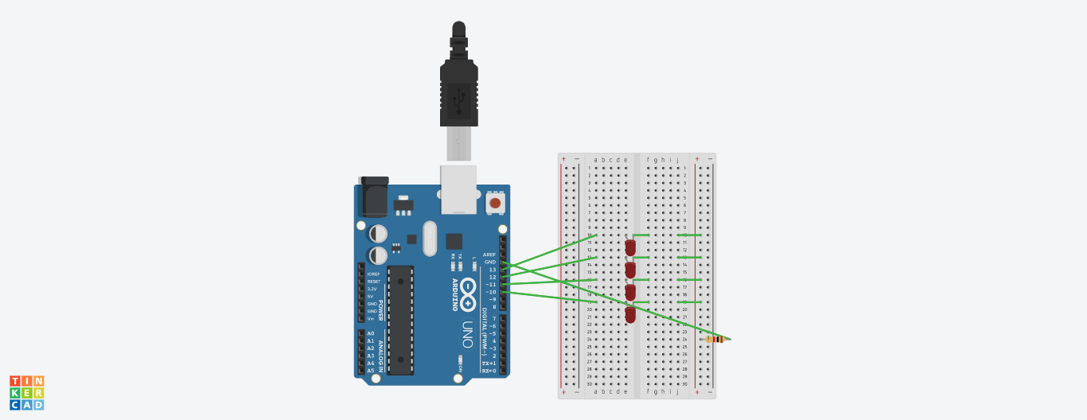

**THEORY**

**CONCEPT USED:-**

Here we will use the concept of multimeter, breadboard, arduino UNO, LEDs and connections. We have connected positive terminal of LED with pins in arduino UNO and negative terminal is grounded.

KIRCHOFF’S CURRENT LAW:-

This law states that the current going in the junction is equals to the current flowing out of the junction.

OHM’S LAW:-

It states that current through a conducter is directly proportional to the voltage across the two points provided that the physical condition such as temperature remains constant.

**V=IR**

**LEARNING AND OBSERVATION:-**

Blinking of LEDs was verified after uploading the program.

1. We observed that firstly, two LEDs glow and then the first LED goes off and third start glowing. In similar manner the chain is formed.
2. We learn how to make various connection in series and parallel circuits
3. We also learn making various connections of LEDs

**PROBLEMS AND TROUBLESHOOTING:-**

The problem faced while the task were:-

1. Code of LED Chaser was written wrong due to which our circuit was not working.
2. The connections went wrong so I had to change the connections and that’s why LED was not blinking.

**PRECAUTIONS:-**

1. Double check the circuit and breadboard diagram to make sure all the components in the right place.
2. Hands should not be wet while working with the circuits.
3. The circuit must be closed.

**LEARNING OUTCOMES:-**

I learned that how we work with Arduino UNO and breadboard and how to make connectionsto start the blinking of LEDs.

I learned making circuits using different hardwares and controlling the functions done by circuit with the program.